## API Automation Testing Approach:

### Sample:

## 

### Approach:

This can be automated using

* Postman
* Rest assured - can be used with unit testing frameworks Junit and TestNG.
* Cucumber/Selenium

### Test scenarios

Below are the scenarios that can be automated:

As the API is for the GET request, and the URL is “/api/accounts” it gets the details of all the accounts.

#### Verification points:

* Query the database to get the list of accounts to be shown as part of the response and the list of accounts should match the response from the API.
* Check for the Status code 200 OK
* Check if the response code is 204 (No content)
* 401 unauthorised error response, when no proper authorisation details provided
* 500 (Internal Server Error)
* Validate the attributes of the response for the datatypes string, integer respectively.
* Validate SubscriptionName, accountName, compositeName display the String variables and SelectedAccountIndex displays the Integer value and the value is “0”.
* Check for Invalid url

### Postman

#### Test design in postman using the mock server

1. Import the collection as file

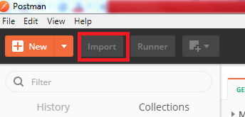

1. Import the json file “TestAPIAccount.postman_collection”

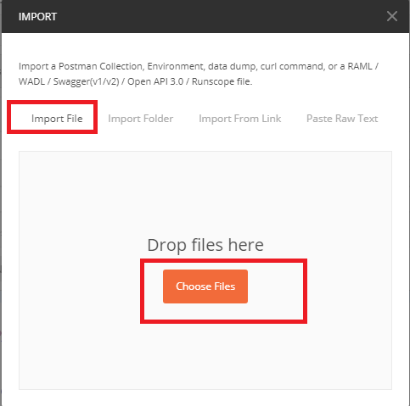

1. Mock server creation (Incase created mock server is not available in the import file sent)
2. 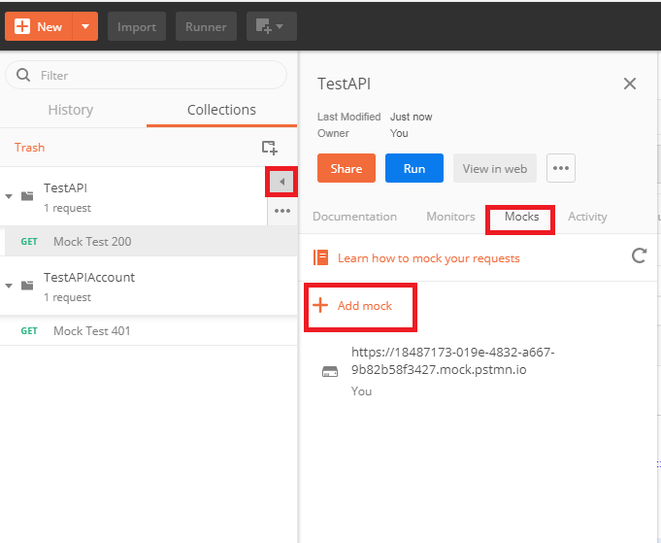

Create two mock server’s each for the collection

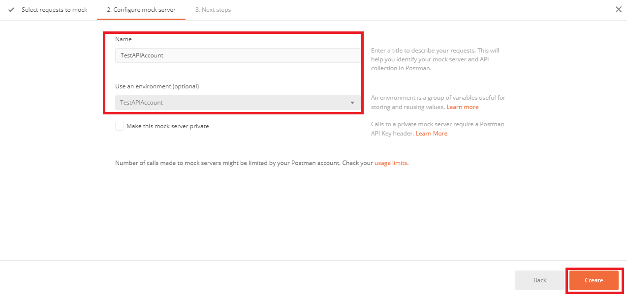

1. Test case : Verification for 200 response code:

* Mock server returns the response in the Json format with the status code 200 ok,

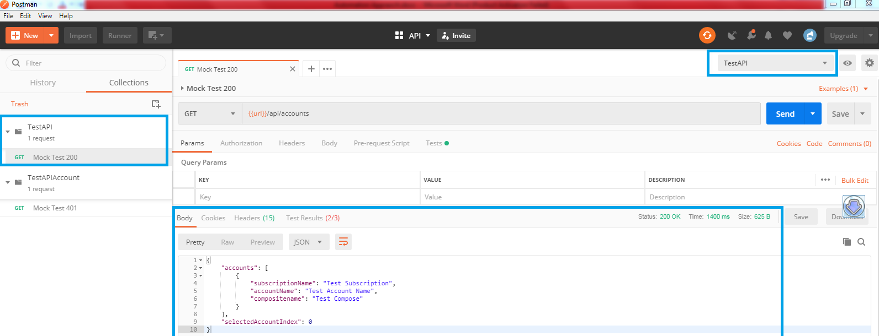

* Automated tests written in the Tests tab verify the test results :

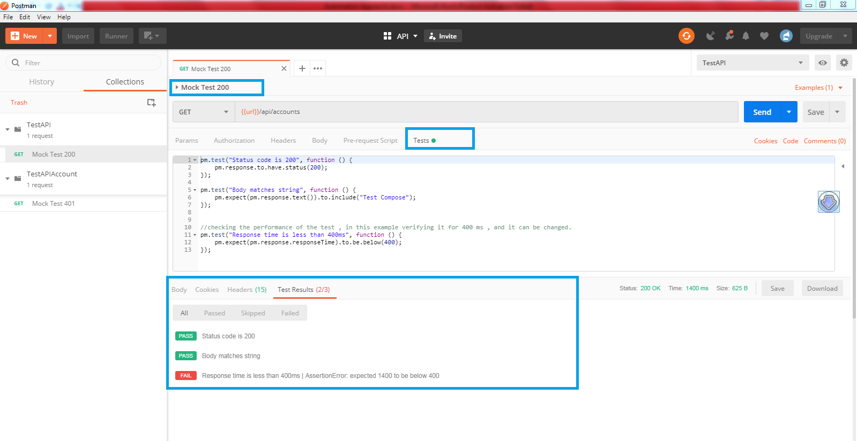

In the above example 🡪

* 2 tests passed and one failed
* The test case related to response time failed , the output response time is 449ms and the test is written to verify for 400ms
* In the similar fashion, automated tests can be written to cover various other scenarios

1. Verification for 401 unauthorised error:

Select “Mock Test 401” request

Click on send button

It shows Json response : “401 Unauthorised” error

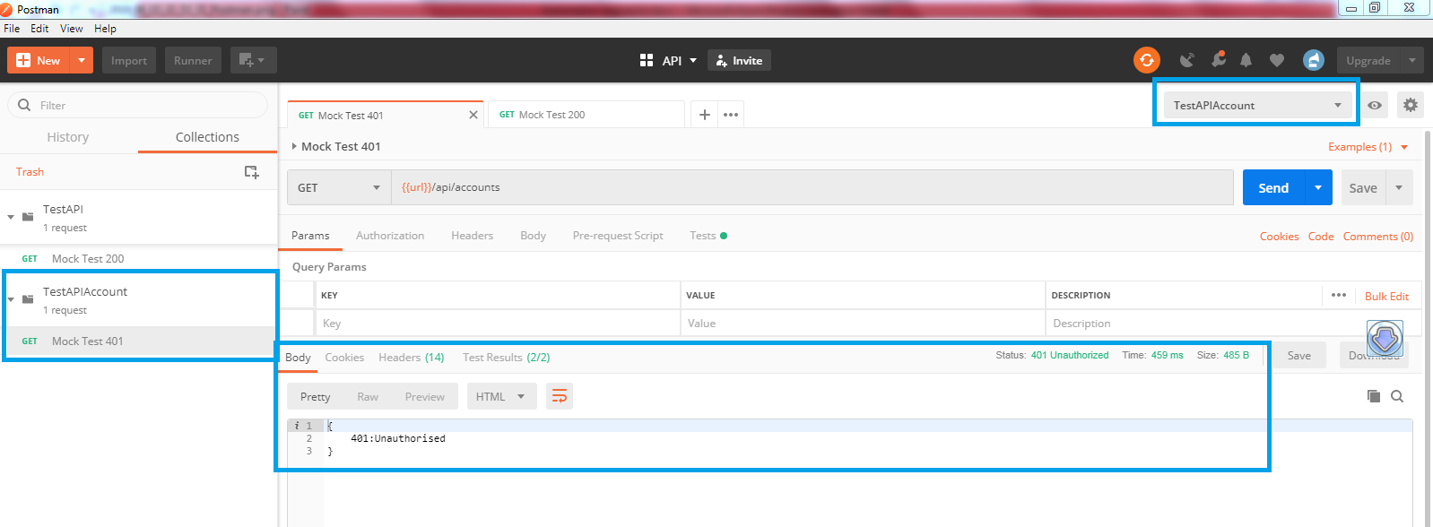

Automated Tests:

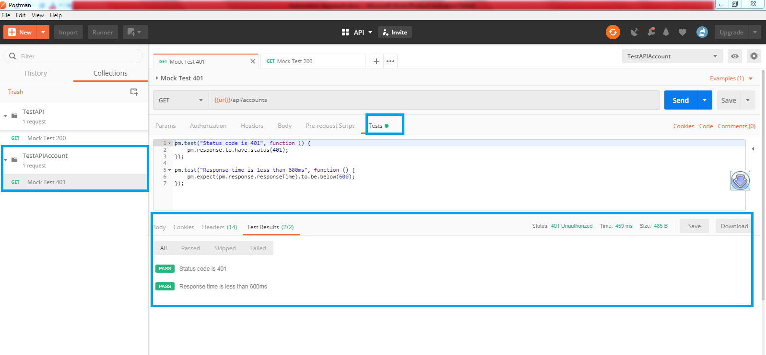

Two tests were written

* To check 401 error
* The response time and the test cases passed